CSC2042S: Assignment 1 - Perceptron Image Classification Report

In this project, I extended a binary perceptron to 10-class classification using the Simpsons-MNIST dataset. I used a one-vs-rest approach, with one binary perceptron for each character, tested both grayscale and RGB images and investigated hyperparameters, stopping criteria, and data augmentation.
- OOP Design
I used two classes: BinaryPerceptron and MultiClassPerceptron. My BinaryPerceptron class stores the weights, bias and learning rate. I initialised the weights and bias to 0.1. The net_input() method calculates the weighted input plus bias, while predict() returns 0 or 1. The apply_learning_rule() method updates the weights and bias using the perceptron learning rule.
My MultiClassPerceptron contains 10 Binary Perceptrons, one for each character. During training, I gave the correct class a target of 1 and all other classes a target of 0. For prediction, I compared the raw net-input scores from all 10 perceptrons and choose the class with the highest score. This design uses composition and allows me to reuse the same training function for both models.
- Hyperparameter Tuning
I tested 3 learning rates (α = 0.1, 0.01, 0.001) and 3 normalisation methods (none, min-max, z-score). I trained each configuration for 20 epochs and used validation accuracy to compare them.
Model | Best validation accuracy | Best setting
Grayscale | 26% | Min-max, α=0.1 or 0.001
RGB | 43% | Min-max, α=0.001
I found that min-max normalisation performed best overall. For grayscale, no normalisation gave only 21 - 23%, while z-score gave around 24 - 25%. For RGB, min-max gave the best result, although it dropped to 38% at α=0.1.
I selected min-max + α=0.001 for both final models because the validation accuracy was noisy and there was no clear benefit from the higher learning rate.
The validation accuracy often changed by 5 - 15 percentage points between epochs. This suggests that the data is not linearly separable and that the perceptron keeps correcting some errors while creating others.
However, one limitation is that I used one seed for each hyperparameter configuration, so the shuffle order may have affected the results.

- Stopping Criteria

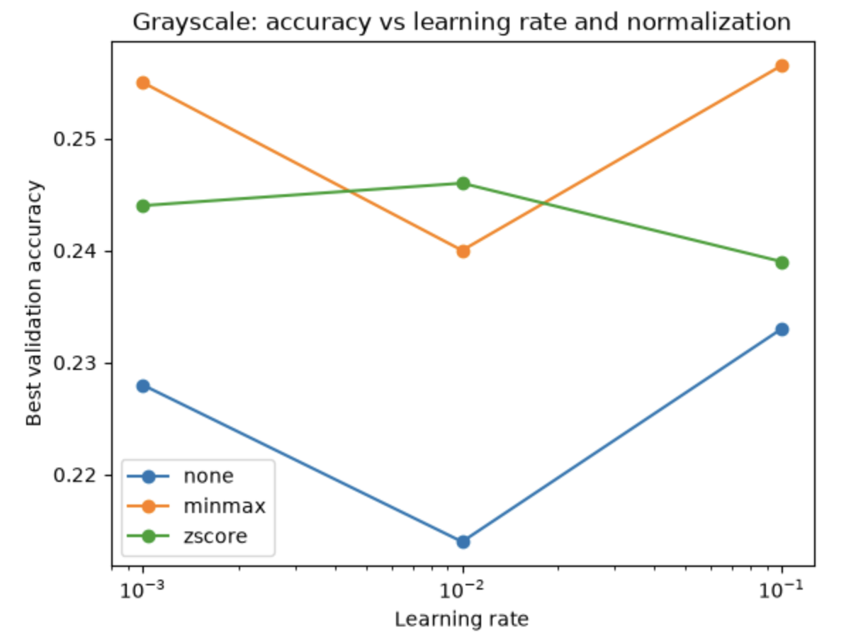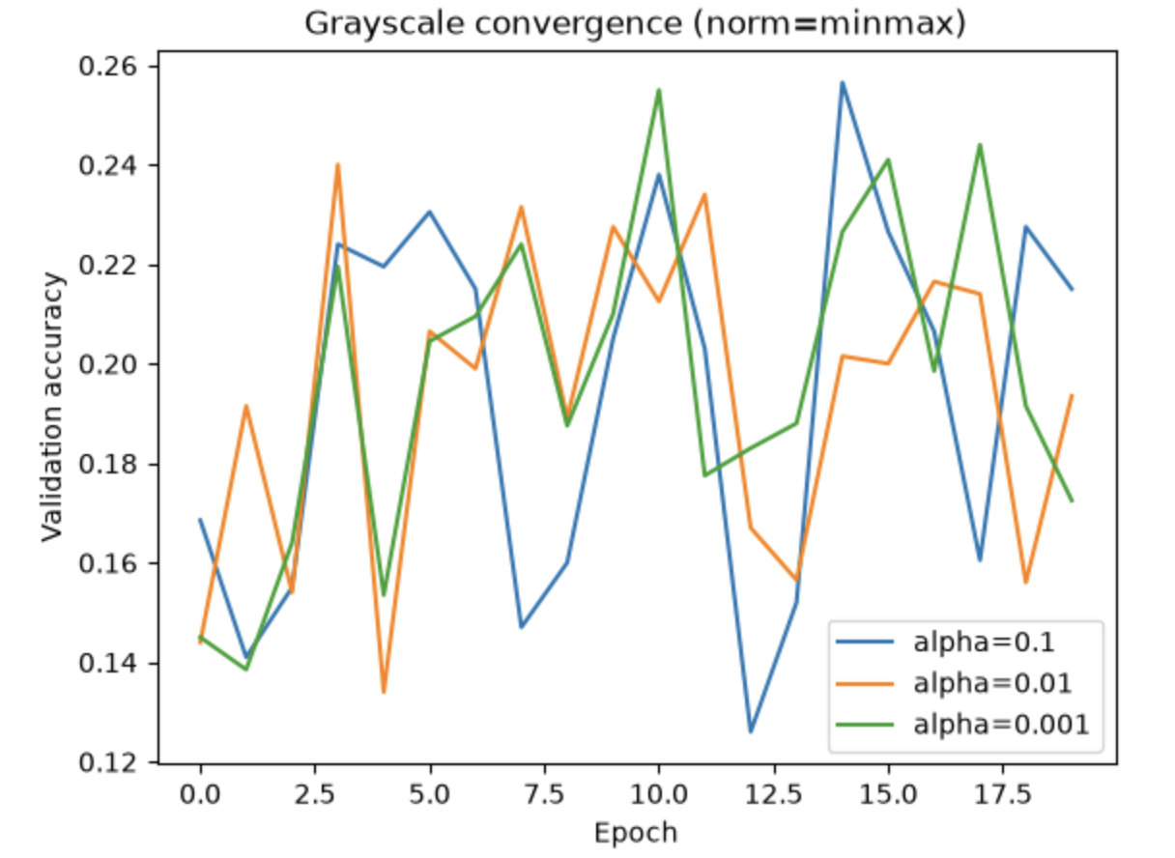

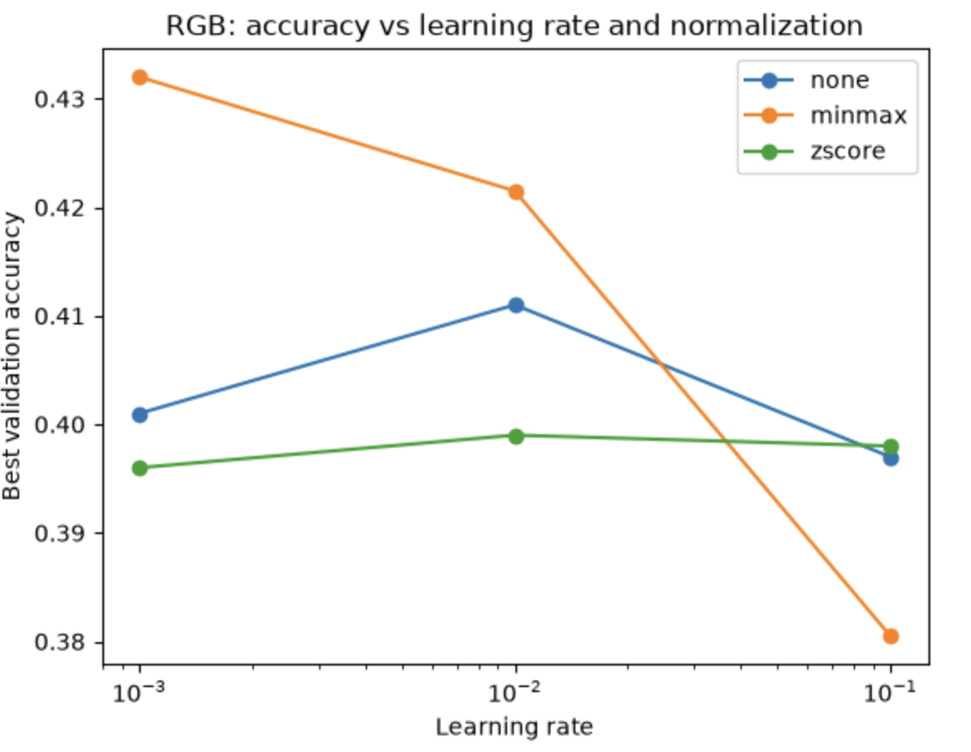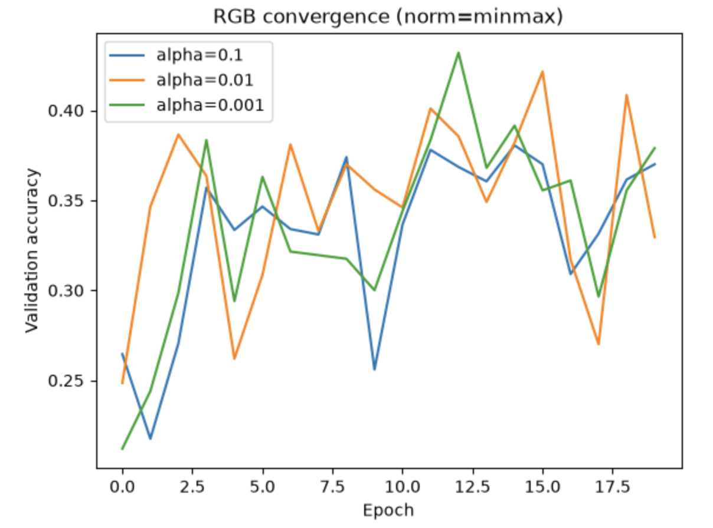
I compared two approaches:
- Fixed: train for 20 epochs.
- Early stopping: stop when validation accuracy does not improve for 3 epochs.
For grayscale (α = 0.01), I reached a best validation accuracy of 24% at epoch 4, and early stopping stopped training at epoch 7. The fixed 20-epoch approach reached a similar 24 - 25%. For RGB (α = 0.1), I reached 36% at epoch 4, and training stopped at epoch 7. The fixed approach reached 38 - 40% over the 20 epochs.
Therefore, early stopping saved 13 epochs, although the fixed approach sometimes achieved slightly higher accuracy. Because validation accuracy was noisy, I found it useful to keep the best-performing epoch/model.

- Validation and Test Results

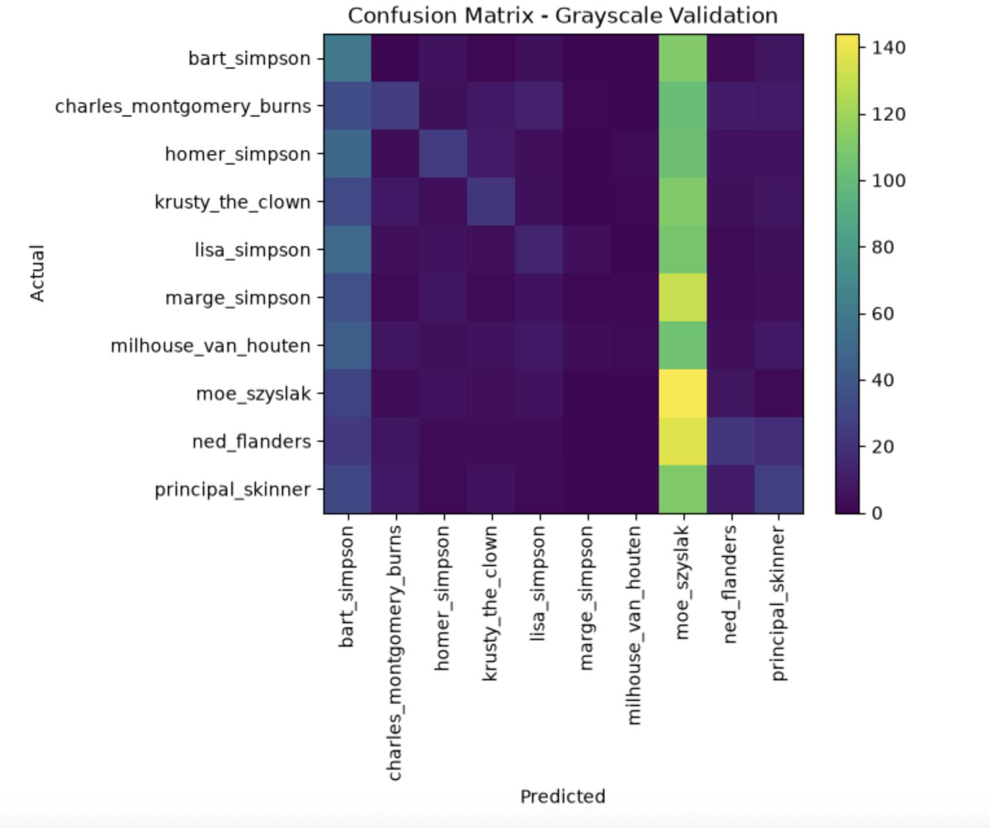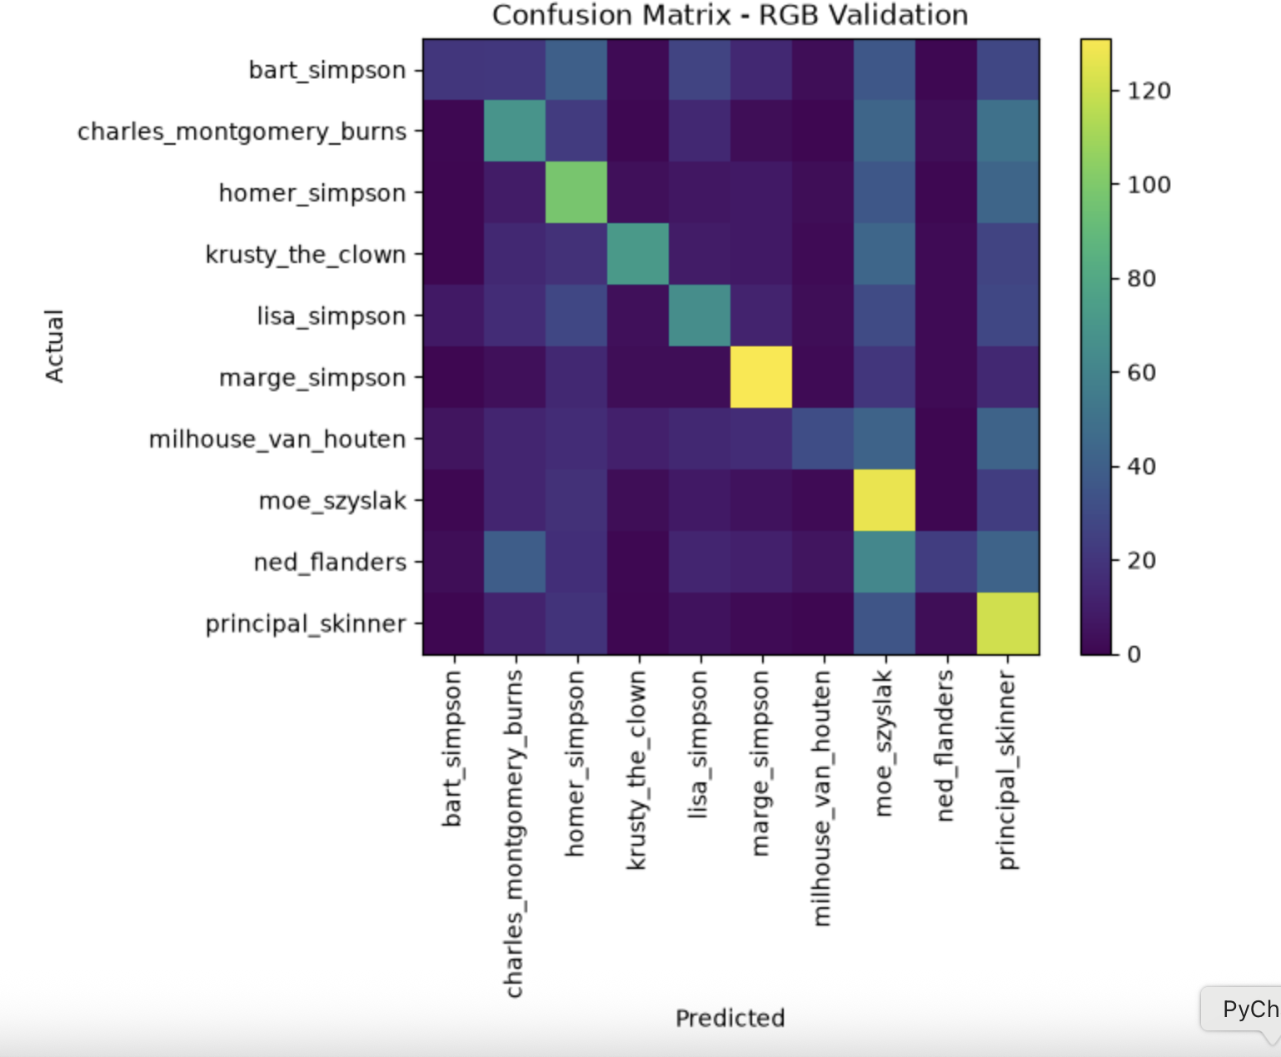

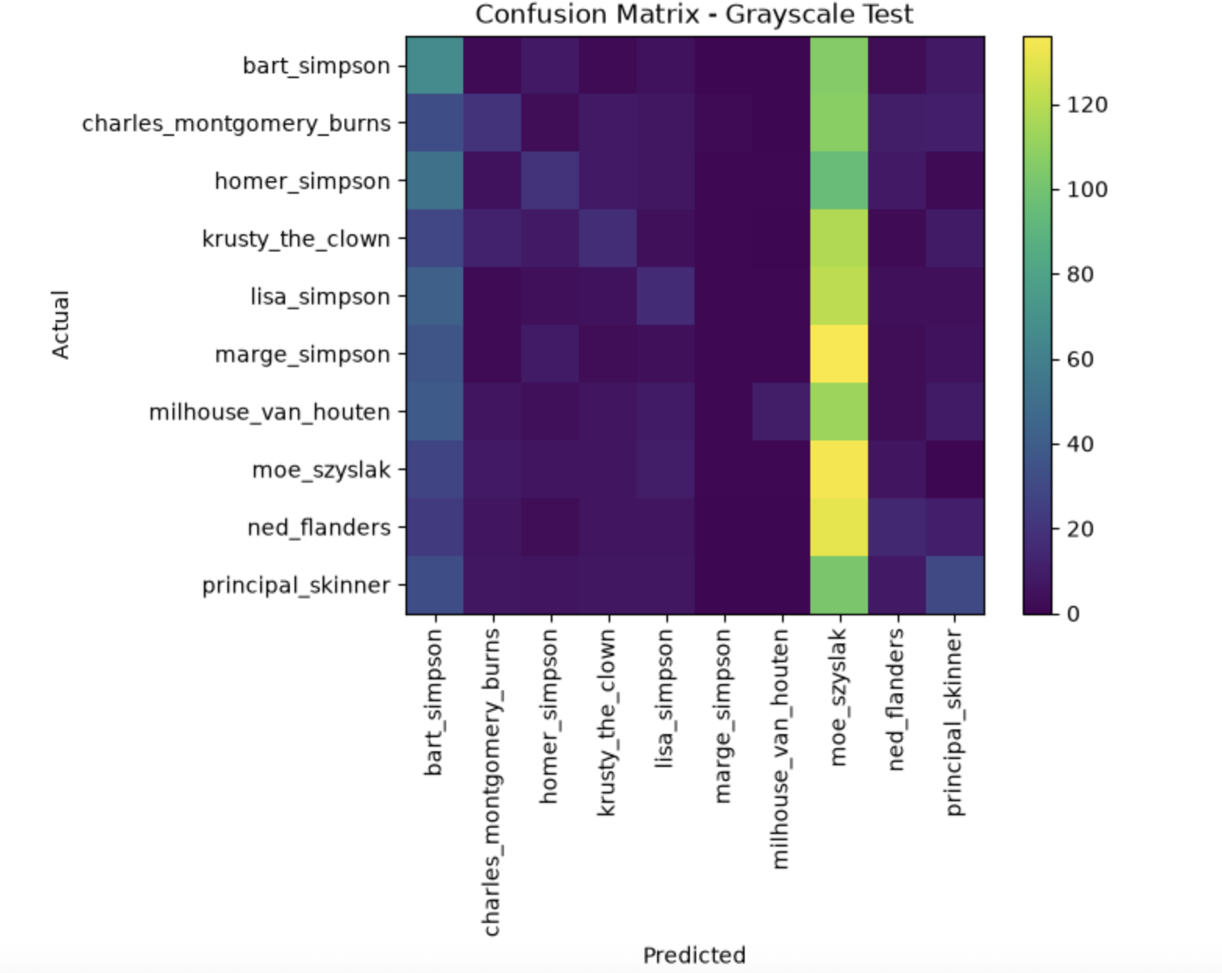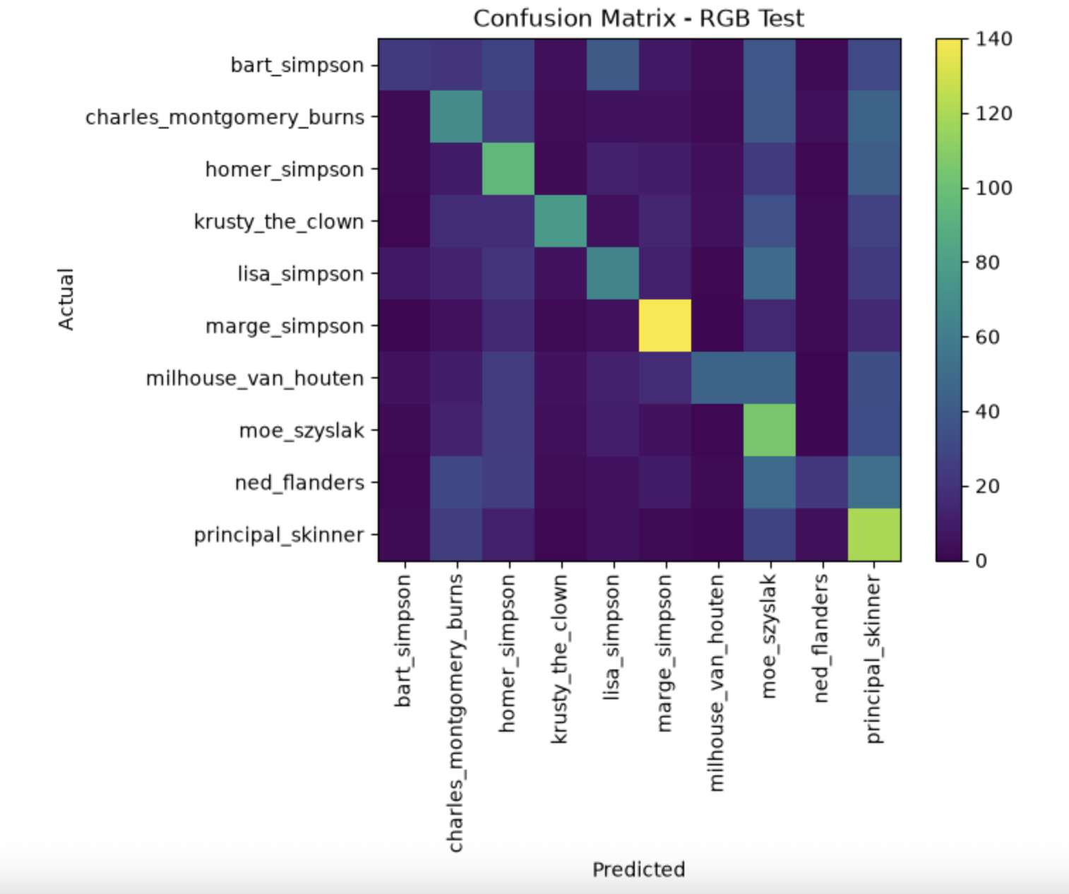
I evaluated my final models on both validation and test data.
Model | Val. Accuracy | Test Accuracy | Test F1
Grayscale | 17% | 16% | 0.14
RGB | 38% | 38% | 0.37
I found that RGB performed much better than grayscale. The similar validation and test results also suggest that my validation results gave a reasonable estimate of test performance.
The grayscale model strongly predicted Moe, with 67% test recall, while Marge had 0% recall. This shows that the grayscale model struggled to distinguish several characters.
The RGB model was more balanced. Marge was my strongest class, with 70% recall and 0.66 F1, while Krusty had the highest precision at 0.71. However, I still struggled with Bart and Ned, which had recall values of around 0.11 - 0.12.
Overall, these results suggest that colour provides useful information for distinguishing the characters.

5. Data Augmentation
I tested no augmentation, brightness changes and rotation using five different seeds.
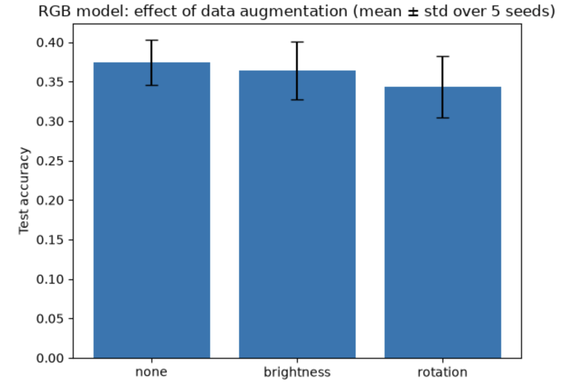
Augmentation | Mean test accuracy | Std
None | 37.4% | 2.9%
Brightness | 36.4% | 3.7%
Rotation | 34.3% | 3.9%
I found that no augmentation had the highest mean accuracy. Brightness was slightly lower, while rotation performed worst. However, the differences were fairly small compared with the standard deviations, so I cannot say that augmentation definitely reduced performance. It simply did not give me a clear improvement. I think rotation was less effective because my perceptron uses flattened pixel values, so moving features to different pixel positions can make learning harder. Brightness keeps the same pixel positions, so it was less disruptive.

Overall, I found that:
- RGB performed much better than grayscale: 38% vs 16% test accuracy.
- Min-max normalisation with α=0.001 was the best final setting.
- Early stopping reduced unnecessary training.
- Data augmentation did not clearly improve performance.
- The RGB model was more balanced across classes, although some characters were still difficult to classify.
- My results also show the limitations of using a linear perceptron with flattened pixels for image classification.

References + AI Declaration
I used Google Gemini in this assignment for debugging, code review (help with which methods/functions I could consider researching/looking into), and feedback on my written analysis, proofreading my comments+docstrings on functions/methods. I would say what influenced most towards my final submission was the debugging as it meant I could continue without problems for the rest of the tasks.
External library documentation consulted for standard function usage:
Pillow (Image.open(), .convert(), Image.fromarray(), .rotate()), NumPy (array operations, random sampling functions), Matplotlib (plt.plot, plt.imshow, plt.colorbar), and scikit-learn (accuracy_score, precision_recall_fscore_support, confusion_matrix)
Sites Visited:
https://scikit-learn.org/stable/auto_examples/ensemble/plot_gradient_boosting_early_stopping.htmlhttps://scikit-learn.org/stable/auto_examples/ensemble/plot_gradient_boosting_early_stopping.html
https://machinelearningmastery.com/implement-perceptron-algorithm-scratch-python/

